# Onboard Computer Options

## Guides

<http://shervinemami.info/embeddedVision.html>

|  |  |  |  |  |  |  |
| --- | --- | --- | --- | --- | --- | --- |
| Board | Raspberry Pi v3 Model B | ODROID-XU4 | Up Squared  [(oem)](http://www.up-board.org/upsquared/) | UDOO x86 Advanced PLUS [(oem)](http://www.udoo.org/udoo-x86/) | Jetson TX1/2 + CTI Orbitty  or Auvidia J120 | DJI Manifold (Tegra K1) |
| Release | 2016 | Feb 2016 | May 2017 | Q2 2017 | K1: Q2 2014  X1: Q2 2015  X2: Q1 2017 | K1: Q2 2014 |
| CPU | Broadcom BCM2387 chipset, 1.2GHz 64 bit Quad-Core ARM Cortex-A53.802.11 b/g/n | Samsung Exynos5422 Cortex™-A15 2Ghz and Cortex™-A7 Octa core CPUs | Various intel | Braswell series  Quad-core Intel Celeron N3160, up to 2.24GHz  (INTEL PENTIUM N3710 2.56 GHZ on Ultra)  Intel Quark SER core 32MHz microcontroller | Tegra X1 (  4 CPU-cores, 64-bit ARM® CPU 4x A57 2MB L2  ARMv8 [ARM Cortex-A57](https://en.wikipedia.org/wiki/ARM_Cortex-A57) quad-core + ARM Cortex-A53 quad-core (64-bit)  A57: 1.9 GHz A53: 1.3 GHz | NVIDIA 4-Plus-1™ Quad-Core ARM Cortex-A15 "r3"  2.3 GHz |
| Architecture | ARMv8 64bit | ARMv8 64bit | x86-64 | x86-64 | ARMv8 64bit | ARM 32bit |
| Memory | 1GB LPDDR2 | 2GB LPDDR3 | 8GB LPDDR4 | 4 GB DDR3L Dual Channel (8GB on Ultra) | 4 GB 64 bit LPDDR4 25.6 GB/s | 8GB 64bit DDR3L and LPDDR3  17 GB/s  ARM Large Physical Page Extension (LPAE) supports 1 [TiB](https://en.wikipedia.org/wiki/Tebibyte) (240 bytes). The 8 [GiB](https://en.wikipedia.org/wiki/Gibibyte) limitation is part-specific. |
| GPU | Dual Core VideoCore IV® Multimedia Co-Processor. Provides Open GL ES 2.0, hardware-accelerated OpenVG, and 1080p30 H.264 high-profile decode. Capable of 1Gpixel/s, 1.5Gtexel/s or 24GFLOPs with texture filtering and DMA infrastructure | Mali-T628 MP6  Hardkernel:  OpenGL ES 3.1  OpenCL 1.2  Jiffy:  OpenGLES 3.0  OpenCL 1.1 | Intel Gen 9 HD 500 or HD 505 | Intel HD Graphics 400, UP TO 640 MHZ,  (INTEL HD GRAPHICS 405 UP TO 700 MHZ on Ultra) | **NVIDIA Maxwell 256-core GPU** DX-12, OpenGL 4.5, NVIDIA [CUDA](https://developer.nvidia.com/about-cuda)®, OpenGL ES 3.1, AEP, and Vulkan | NVIDIA® Kepler™ Architecture  192 NVIDIA CUDA® Cores |
| OS | Raspbian, linux, Windows 10 IOT | Linux Kernel 4.9 LTS  Android <= 7.1 Nougat | Win IOT, Win 10, Ubuntu, Ubilinux, Android Mrshmllw | All x86_64 OS | Ubuntu | LX4T (Ubuntu variant) |
| POWER | 5V, 2.5A | 5V, 4A |  | 12V | 9-15V  TX1: 6.5-15W  Orbitty: 2-6W  K1: 20 nm SOC - TSMC Isolated Power Rails, Fourth-Generation Cluster Switching |  |
| TDP | 12.5 W max | 20 W max |  | 5 or 6 Watts | TDP 15 watts, with average power consumption less than 10 watts | Power consumption: 8 watts |
| IO | 802.11n Wifi  Bluetooth 4.1  Bluetooth LE  4xUSB2.0  40pin GPIO  HDMI  1xGbE  3.5mm audio + composite video  CSI(Camera)  DSI(Display) | eMMC5.0 socket  HDMI  MicroSD  Ethernet  4pin Serial  30pin GPIO  12pin GPIO  2x USB3.0  1x USB2.0  Note: GPIO pins at 1.8V, needs shifter shield to raise to 3.3V or 5v | SATA3  2xHDMI  Displayport  2xGbE  1x2laneCSI  1x4laneCSI  Pi 40pim GPIO | Ethernet  HDMI  2x UART  3x USB3.0  eMMC storage  MicroSD  SATA  Arduino 20pin  IR  LPC  2xI2C  RTC Battery  3.5 mm jack  M.2 Key E slot for optional Wireless modules | **Orbitty:**  1xGbE  1xUSB3.0  1xUSB2.0  HDMI  1xMicroSD  2xUART  I2C  4xGPIO  **J120-IMU:**  HDMI  GbEthernet  2xUSB3.0  1xUSB2.0  1xCSI-2 for B102  2x UART  2x DSI  SPI/GPIO  MicroSD  I2C  MPU9250-IMU included | CAM_IN and CAM_OUT  HDMI - 4K (UltraHD, 4096x2160) |
| VIDEO IO |  | HDMI  1080p via HDMI cable(H.264+AAC based MP4 container format) |  | HDMI  2xminiDP++  HW Video decode: H.265/HEVC, H264, MPEG2, MVC, VC-1, WMV9, JPEG, VP8; HW Video encode: H.264, MVC, JPEG | **TX1:**  **H.265, VP9 4K 60 fps Video** 4k H.265, 4k VP9, 4k H.264  **4K x 2K @60 Hz, 1080p @120 Hz** HDMI 2.0 60 fps, HDCP 2.2 |  |
| Size | **85mm x 56mm**  **H: 17mm** | **83mm x 58mm**  **H: 22mm** | **85.6mm x 90mm** | **120mm x 85mm** | **TX1 + Orbitty/J120:**  87mm x 50mm  Height: full stack: 30.18mm | **23x23 FCBGA 16x16 S-FCCSP 15x15 FC PoP** |
| PRICE | **$64.35 AUD**  [jiffy(au)](https://jiffyshop.com.au/SBC/raspberry-pi/108-raspberry-pi-3.html) | **$149.95 AUD**  [jiffy(au)](https://jiffyshop.com.au/SBC/21-odroid-xu4) | **$145 USD to $269 USD** | **$253.54 AUD**  [mouser(au)](http://au.mouser.com/search/refine.aspx?Ntk=P_MarCom&Ntt=141139014) | **TX1:**  $759 AUD  With DK board  [ubuy(us,au)](https://www.u-buy.com.au/catalog/product/view/id/1046146/s/nvidia-jetson-tx1-development-kit-proprietary-ddr4-motherboards-945-82371-0000-000?sku=B017NWO6LG&store=US)  **TX2:**  $790 AUD with DK board  [newegg(au)](https://www.newegg.com/global/au/Product/Product.aspx?Item=N82E16813190007&Tpk=32gb%20ram)  [xenon(au)](http://www.xenon.com.au/product/nvidia-jetson-tx2-developer-kit/)  **Orbitty:**  $356 USD  $474.54 AUD  ($230.61 AUD + $243.93 AUD shipping, flat rate)  [wdl(us)](http://www.wdlsystems.com/Computer-on-Module/Carrier-Boards/CTI-Orbitty-Carrier-for-NVIDIA-Jetson-TX1.html)  **Orbitty+TX1**:  $823.00 USD  $1097.04 AUD  [wdl(us)](http://www.wdlsystems.com/Computer-on-Module/TX1Bundles_CTI/-NVIDIA-TX1-Integrated-Bundle.html)  **J120:**  € 268,90  $379.64 AUD  ($309.19 AUD + $70.45 AUD shipping, flat rate) | $859 AUD  [risabove(au)](http://www.riseabove.com.au/dji-manifold) |
| USE Cases | Delivery | HD Image capture + image processing or advanced navigation  Lacks CSI  Can get USB images |  | Fast + Parallel CPU processing | Multi Image Processing | Single Image Processing |

# Combinations

## Earl-Brain

<https://erlerobotics.com/blog/product/erle-brain-3/>

BeagleBone Black or Raspberry Pi Zero + PixHawk Fire Cape

Simple linux autopilot

<http://ardupilot.org/dev/docs/beaglepilot.html>

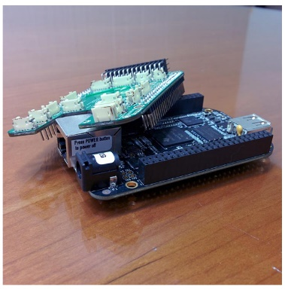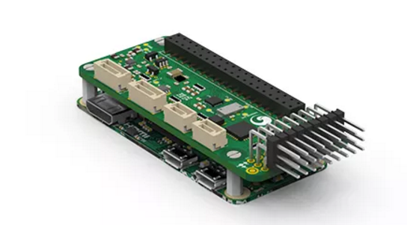

# Links and Notes

## Raspberry Pi

## ODROID-U3

<http://hardkernel.com/main/products/prdt_info.php?g_code=G138745696275>

## ODRIOD-XU4

<http://hardkernel.com/main/products/prdt_info.php?g_code=G138745696275>

<https://jiffyshop.com.au/SBC/21-odroid-xu4>

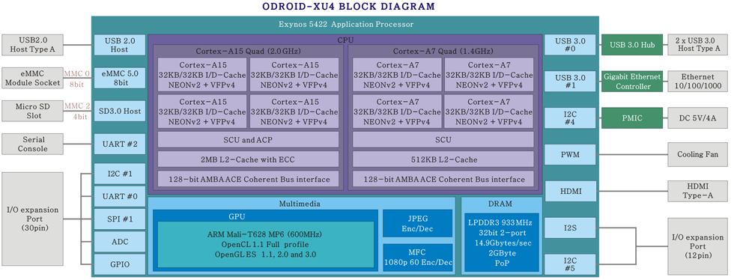

## XU4CPUperformance.jpg

## Gumstix Overo

## Udoo x86

<http://www.udoo.org/udoo-x86/>

<http://au.mouser.com/new/udoo/udoo-x86/>

Pre-Order from main distributor

## 10 times more powerful

## NVIDIA Jetson TK1

<http://www.fishpond.com.au/Electronics/NVIDIA-Jetson-TK1-Development-Kit/0850438005456>

# NVidia Jetson TX1

<http://www.nvidia.com/object/tegra-x1-processor.html>

<http://www.nvidia.com/object/embedded-systems-dev-kits-modules.html>

<http://diydrones.com/profiles/blogs/nvidia-jetson-tx1-carrier-boards-overview>

<http://ardupilot.org/dev/docs/companion-computer-nvidia-tx1.html>

$759 AUD With development kit board

<https://www.u-buy.com.au/catalog/product/view/id/1046146/s/nvidia-jetson-tx1-development-kit-proprietary-ddr4-motherboards-945-82371-0000-000?sku=B017NWO6LG&store=US>

## NVidia Jetson TX2

$790 AUD with Developer Kit board

<https://www.newegg.com/global/au/Product/Product.aspx?Item=N82E16813190007&Tpk=32gb%20ram>

## AuVidia J120

<https://auvidea.com/purchase/>

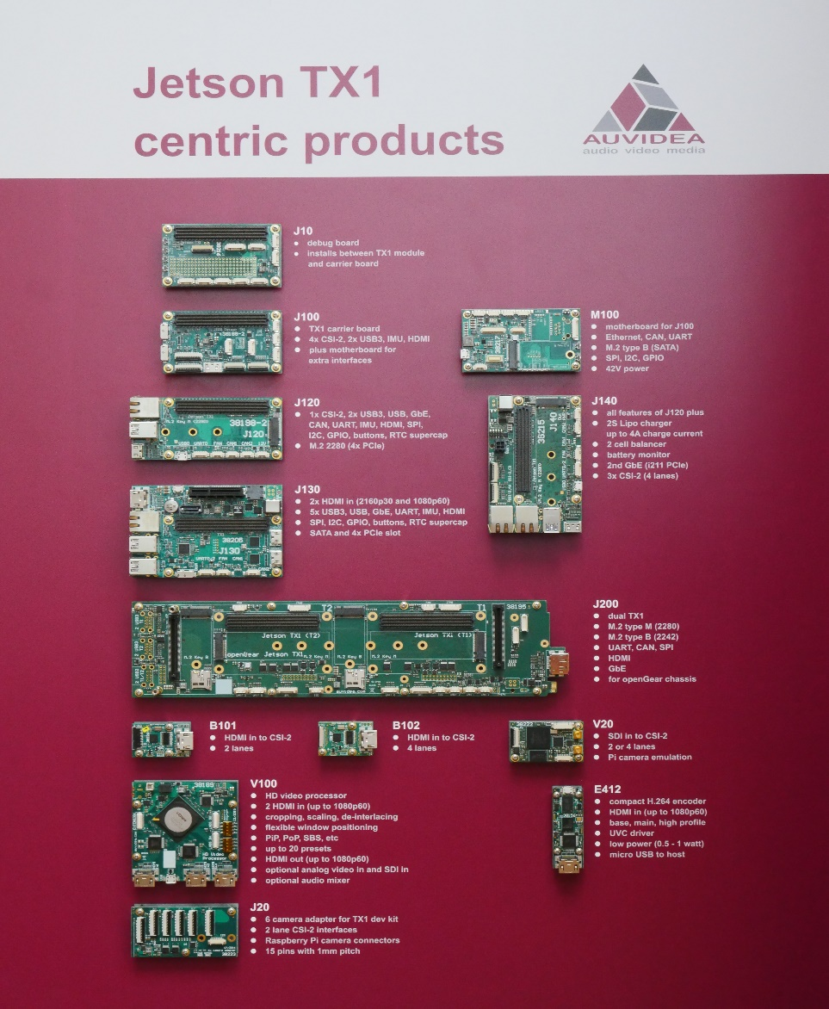

## Orbitty Carrier with Jetson TX1

<http://connecttech.com/product/orbitty-carrier-for-nvidia-jetson-tx2-tx1/>

<http://www.wdlsystems.com/Computer-on-Module/Carrier-Boards/CTI-Orbitty-Carrier-for-NVIDIA-Jetson-TX1.html>

<http://www.connecttech.com/pdf/CTIM-ASG003_Manual.pdf>

<http://www.nvidia.com/object/embedded-systems-dev-kits-modules.html>

## DJI Manifold

<http://www.nvidia.com/object/tegra-k1-processor.html>

$859 AUD

<http://www.riseabove.com.au/dji-manifold>

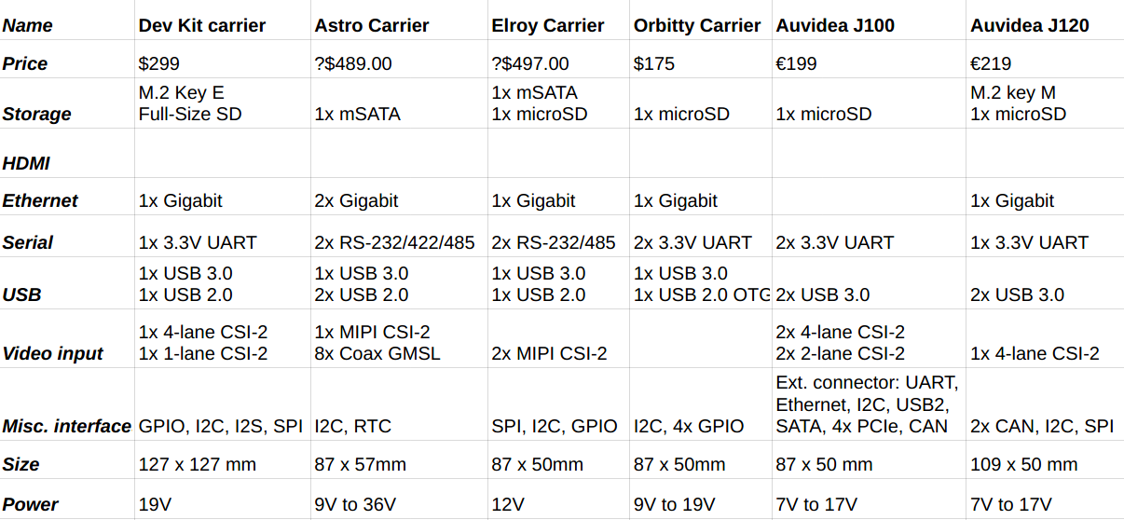

<http://airsoc.com/articles/view/id/573f5ecc313944b4038b4567/nvidia-jetson-tx1-carrier-boards-overview>